APITester

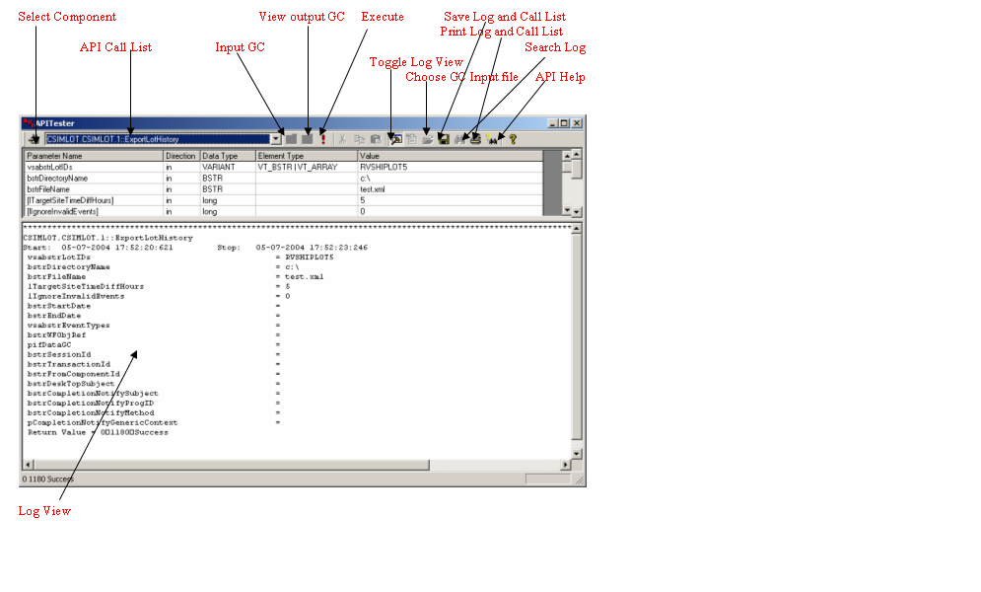

Note
InputGC and OutputGC GUIs can export gc in xml format and same can be imported as input gc by clicking Choose GC Input file Icon as (.xml) files apart from binary (.gc) files.

ISQL

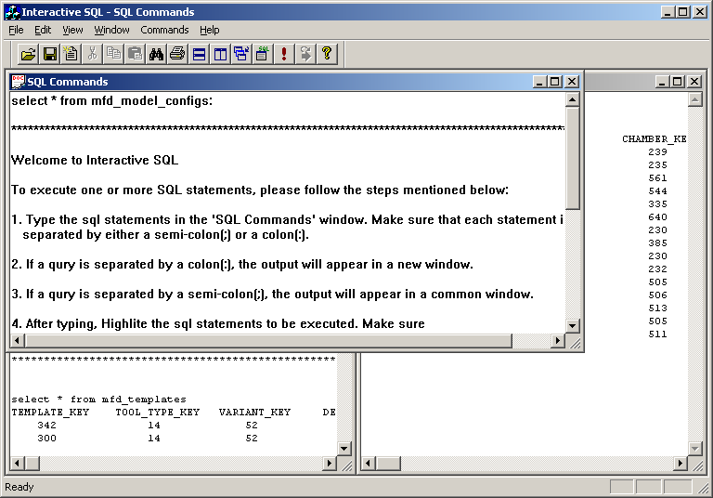

RVVPM

